Logistic Regression

Introduction
Machine learning is a subfield of artificial intelligence that focuses on creating statistical models and algorithms that can learn from data and predict the future. Logistic regression is a type of supervised learning algorithms used in classification problem which uses one or more independent variables to describe the relationship between a dependent (target) and independent (predictor) variables [1].
Model Selection and Rationale
Logistic regression calculates the probability that an input belongs to a specific class, making it for medical diagnosis like predicting MI based on clinical features. Unlike linear regression, which predicts continuous values, logistic regression uses the logistic sigmoid function to transform its output into probability. This probability can then be mapped to one of two or more discrete classes, making it ideal for classification tasks. Therefore, it is well-suited for predicting the presence (1) or absence (0) of myocardial infarction (MI).
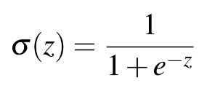
The sigmoid function is a mathematical function that maps predicted values and produces probabilities. In the formula, σ (z)= output between 0 and 1 (probability estimate), z = input to the function and e = base of natural log [2].

Sigmoid function

Implementation
Splitting the features and Target
Take four variables like features_train, features_test, MI_train, MI_test. Put all features to features_train, all testing data to features_test, target of all features to MI_train & corresponding target to MI_test. Split the data to train & test data using the train_test_split function, with 80% allocated for the training and 20% for the testing. The test set is stratified with the help of target class in order to ensure the class balance [3].

Model Training:
Use Logistic Regression training model because it is very useful for binary classification. Train machine learning model i.e. Logistic Regression model with training data. A pattern or a relationship will be found between the features present in training data and the corresponding target. After training the model, use this trained model to predict new values [3]. A Logistic Regression model was created and then trained on features such as age, maximum heart rate, chest pain type, exercise-caused angina and so on.
Model Evaluation:
Evaluate how well the model is performing using various evaluation metrics such as accuracy score [3].
Accuracy: Compared the accuracy on both the training and testing sets in order to determine the extent to which the learning achieved can generalize onto new data.
ROC Curve: The ROC Curve is a simple plot which used to visualize the performance of a binary classifier. Further, this shows the trade-off between the true positive rate and the false positive rate of a classifier for various choices of the probability threshold [2]. The figures show that the methodologies provide increasing AUC values, greater than 0.9, which means a better capability in distinguishing MI and non-MI cases.
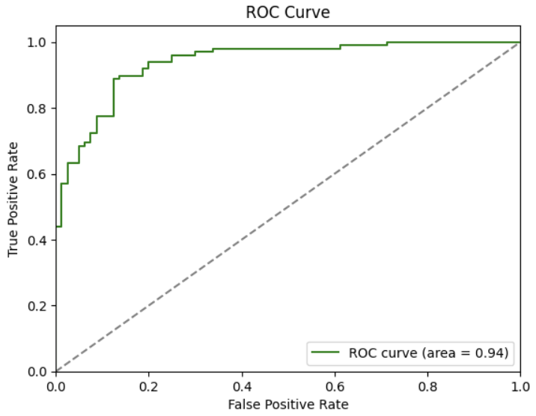
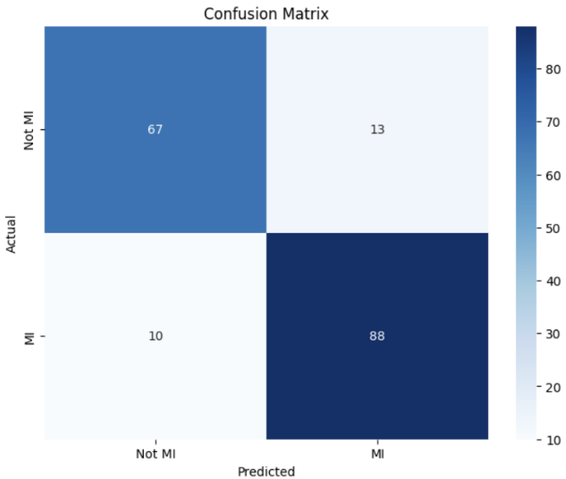
Confusion Matrix: It is a matrix that is used to determine the performance of classification models for a given set of test data [1] [2]. It is applied in order to illustrate the quantities of true positives, true negatives, false positives, and false negatives to state the model’s advantages and disadvantages.

Citation
- R. Bhuvana, Maheshwari, S. and S. Sasikala (2023). Predict the Heart Disease Using a Logistic Regression Classifier Algorithm.
doi:https://doi.org/10.1109/smart59791.2023.10428486.
- Nishadi, A.S.T. (2019). Predicting Heart Diseases In Logistic Regression Of Machine Learning Algorithms By Python Jupyterlab. [online] https://www.ijarp.org/. Available at: http://www.ijarp.org/published-research-papers/aug2019/Predicting-Heart-Diseases-In-Logistic-Regression-Of-Machine-Learning-Algorithms-By-Python-Jupyterlab.pdf.
- Narang, H., Verma, K., Shivam Kumar Shandilya, Satvik Vats, Manish Mohan Baral and Satya Prakash Yadav (2023). A Study on Prediction of Cardiac Diseases Utilising a Machine Learning Approach for Logistic Regression. A Study on Prediction of Cardiac Diseases Utilising a Machine Learning Approach for Logistic Regression, (10.1109/ICUIS60567.2023.00008). doi:https://doi.org/10.1109/icuis60567.2023.00008.

